**Operating Systems Lab Assignment – 2**

**Sub-Task 1:** Initialize the logging configuration to capture timestamped messages.

**Sol.-**

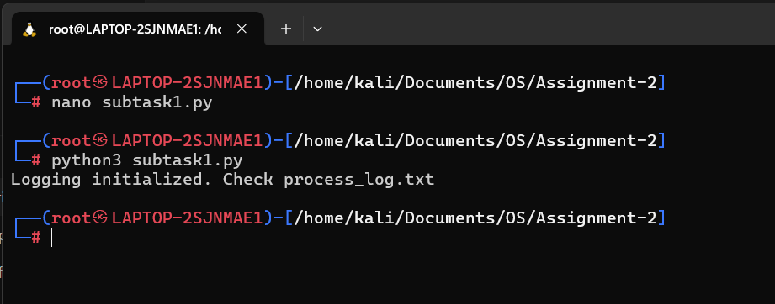

**Sub-Task 2:** Define a function that simulates a process task (e.g., sleep for 2 seconds).

**Sol.-**



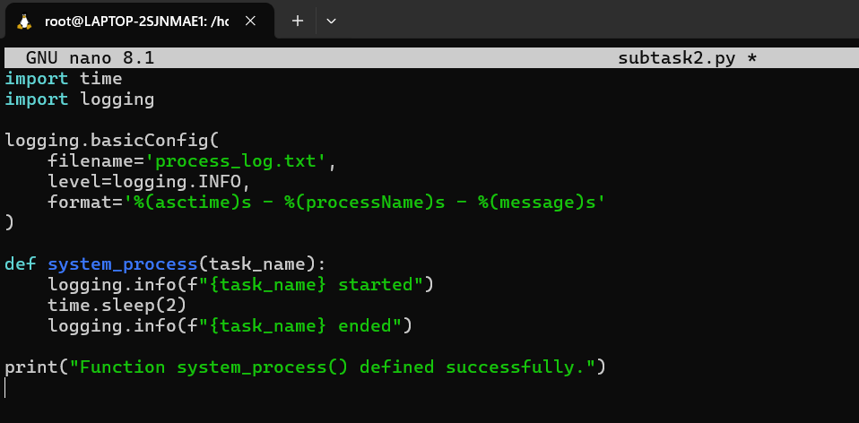

**Sub-task3:** Create at least two processes and start them concurrently.

**Sol.-**

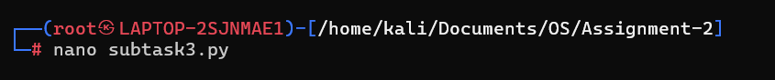

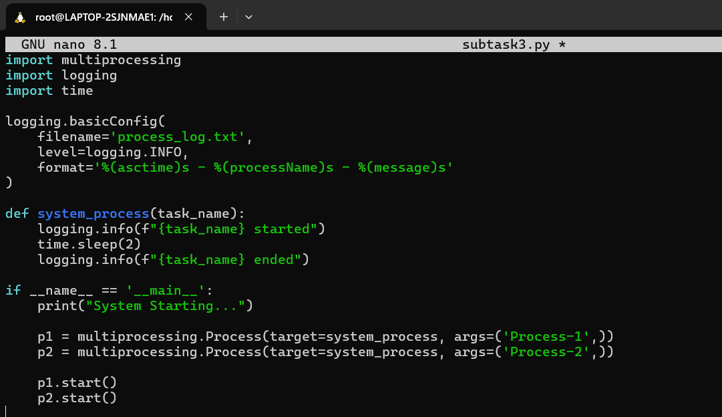

**Sub-Task 4:** Ensure proper termination and joining of processes, and verify the output in the log file.

**Sol.-**



